0.5: Single page app diagram

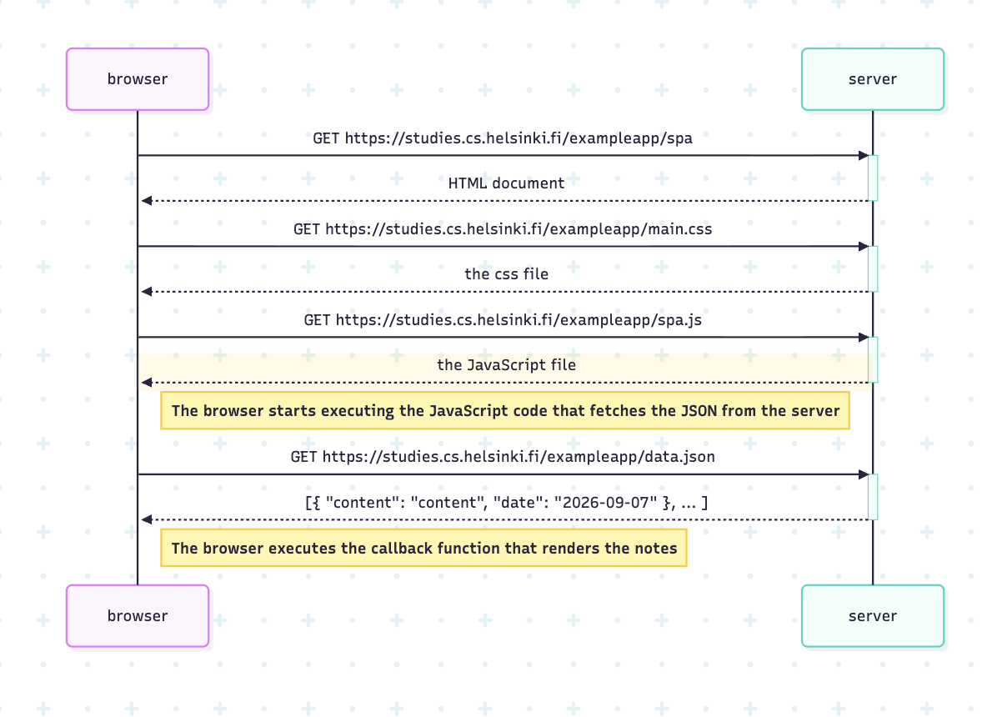

sequenceDiagram
participant browser
participant server
browser->>server: GET https://studies.cs.helsinki.fi/exampleapp/spa
activate server
server-->>browser: HTML document
deactivate server
browser->>server: GET https://studies.cs.helsinki.fi/exampleapp/main.css
activate server
server-->>browser: the css file
deactivate server
browser->>server: GET https://studies.cs.helsinki.fi/exampleapp/spa.js
activate server
server-->>browser: the JavaScript file
deactivate server
Note right of browser: The browser starts executing the JavaScript code that fetches the JSON from the server
browser->>server: GET https://studies.cs.helsinki.fi/exampleapp/data.json
activate server
server-->>browser: [{ "content": "content", "date": "2026-09-07" }, ... ]
deactivate server
Note right of browser: The browser executes the callback function that renders the notes

